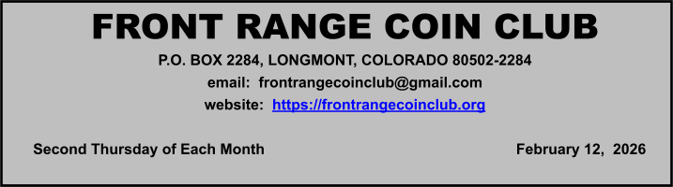

April

12
th

MeetiMinutes

Attendance

27 members attended and one guest.

Meeting Minutes

Old Business:

No old business was discussed at the meeting.

New Business:

Dave A. is selling rolls of the newest issue circulating coins. He has 2025 Women’s quarters for $12.50/roll and the new 2026 Mayflower quarters for $13/roll.

Ken discussed the upcoming Front Range Coin Club Spring Coins and Collectibles show, which is scheduled for March 14-15, 2026 at the Boulder County Fairgrounds. Ken reported that all tables are sold out, and over 1500 postcard reminders have been sent out. Ken passed out signup sheets for volunteers to help with various show activities.

President’s Corner

President Dave Jaeger discussed the silver and gold price drop recently. This was due to backwardation on COMEX, which raised margin requirements to take silver from $120 to $65 to lose contracts. The appointment of Kevin Warsh as the Fed Chairman, who favors a stronger US dollar, also influenced the price of gold and silver downward. Could be a good buying opportunity. American Silver Eagles (ASE), which are being sold at a premium currently (~$98/ea), and 90% constitutional silver are always in demand.

Presentation(s)

Paul DeFilice of ANACS grading, talked about ANACS and answered questions at the February meeting.

ANACS attended 400 coin shows last year and have 21 regional representatives across the country. The reps provide a personal, face-to-face touch to submissions and the show-to-show delivery saves money on shipping. ANACS has 8 graders and each coin is reviewed by a Senior Grader. Even with these extra services, ANACS is usually cheaper than PCGS, NGC, or CACG, which can save collectors and dealers money on submissions that can be used to get that next coin.

Because some of the coin graders have been working at ANACS for 30+ years, their grading is very consistent, and they have avoided “Gradeflation” that can affect the other coin grading services. He indicated that ANACS graders see more coins in a week than most people will see in a lifetime. They routinely see counterfeit coins each week, especially the 1916 D Mercury dime and the 1932 D quarter.

ANACS does not currently grade currency, but is potentially looking into grading sports cards in the next 18-24 months.

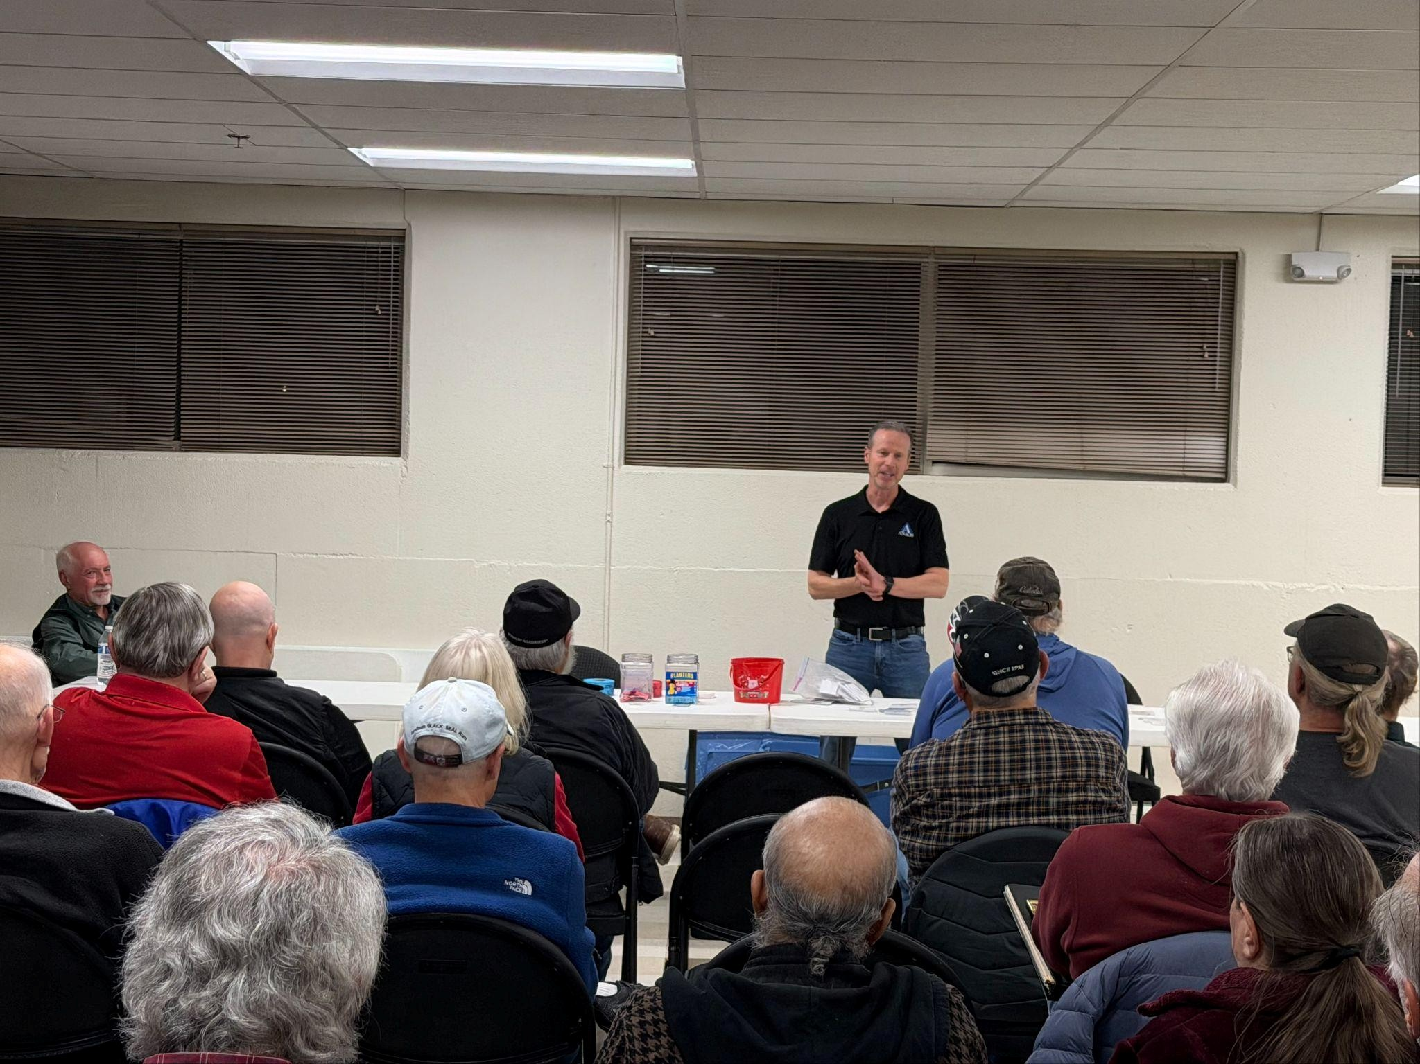

Treasurer’s Report

Bob L. reported the club bank account balance was $20,099.35. Also, he reminded members that club dues for 2026 are due.

Drawings/Door Prizes

Dave F. and Brad T. won prizes.

Coin and Currency News

On Thursday, Feb. 26, the United States
Mint released the 2026-W Proof American
Silver Eagle and the 2026 Congratulations
Set, which includes a 2026-P Proof American Silver Eagle presented in gift-themed packaging. Both products became unavailable within minutes of launch, with the West Point–minted coin lasting the longest at roughly 17 minutes.

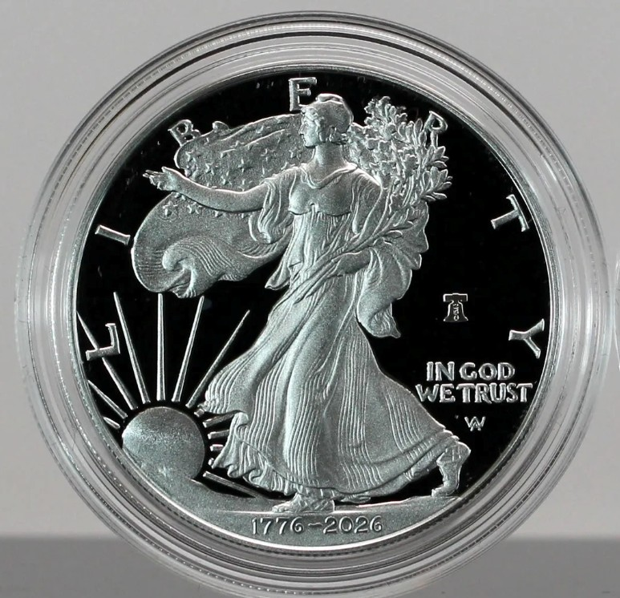

Upcoming Programs

Dave will do a program related to currency next month.

Local Area Coin Clubs

*On average, doors open 30 minutes before the start of a meeting:

Front Range Coin Club:
7:00 PM, Christ Our Savior Lutheran Church, 640 Alpine St, Longmont, CO; 2nd Thursday monthly.

Northside Coin Club:
7:00 PM, Cross of Christ Lutheran Church, 12099 Lowell Blvd, Broomfield, CO; 2nd Tuesday monthly.

South Suburban & DAWN Coin Club:
6:00 PM, Calvary South Denver Church,
9052 W Ken Caryl Ave, Littleton, CO 80128;
2nd Tuesday monthly.

Denver Coin Club:
7:00 PM, Salem United Church of Christ, 5300 E. Florida Ave, Denver, CO; Last Thursday monthly.

Fort Collins Coin Club:
6:30 PM, Senior Center, 1200 Raintree
Drive, Fort Collins, CO;
1st Friday monthly except July & December.

Greeley Coin Club:
7:00 PM, Moose Lodge, 3456 11th Ave,
Evans, CO;
2nd Tuesday monthly. No meetings in July and August.

Cheyenne Coin Club:
7:00 PM, Ascension Lutheran Church, 712 Storey Boulevard, Cheyenne, WY; 3rd Tuesday monthly.

2026 Coin Shows
March:
14th-15th | Front Range Coin Club Spring  Coins & Collectibles Show  Boulder County Fairgrounds, Bldg A  9595 Nelson Road  Longmont, CO 80501  Ken Davis, 303-772-6706
March:
20th-22nd | Fort Collins Coin Club Spring  Coin Show  Larimer County Fairgrounds - McKee 4-H  Bldg.5280 Arena Circle  Loveland, CO 80538

April/May:
April 30th  - May 2nd | Denver Coin Expo  National Western Complex 4655 Humboldt St.  Denver, CO 80216

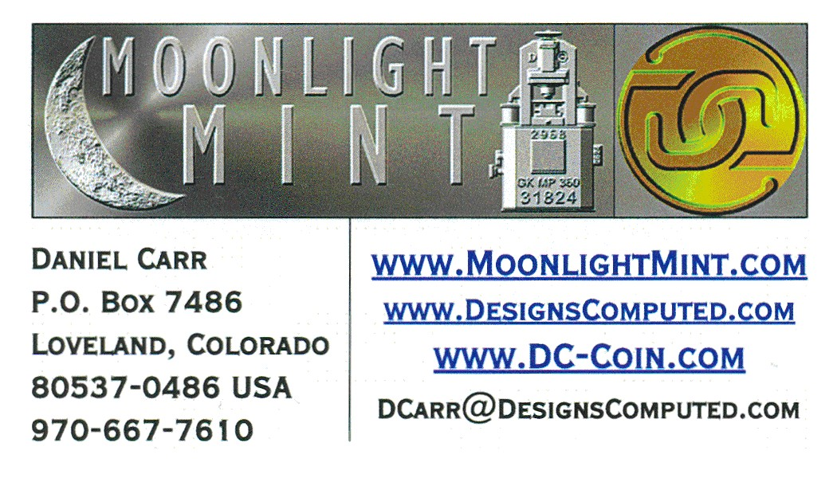

Contact Us - 2026 FRCC Officers

President: Dave Jaeger 970-310-4873 davejaeg@gmail.com
Vice President: Joe Garguilo 303-651-2877
m5joe@yahoo.com
Coin Show Dir: Ken Davis 303-772-6706
krdavis334@msn.com
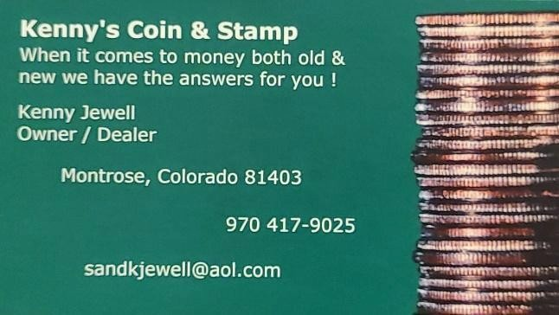
Secretary: John Flahive 262-665-2025 bcwatchman@gmail.com
Treasurer: Bob Liberatore 303-651-1091 ontimeappr@msn.com
Newsletter: John Flahive 262-665-2025 frcc.org@gmail.com

2026 FRCC Board of Directors

Director: Dan Carr 970-667-7610
dcarr@MoonlightMint.com
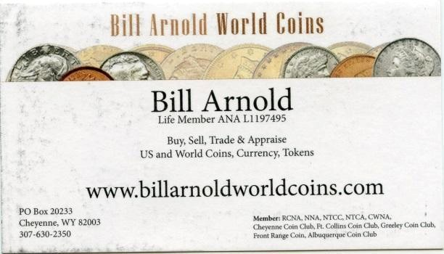
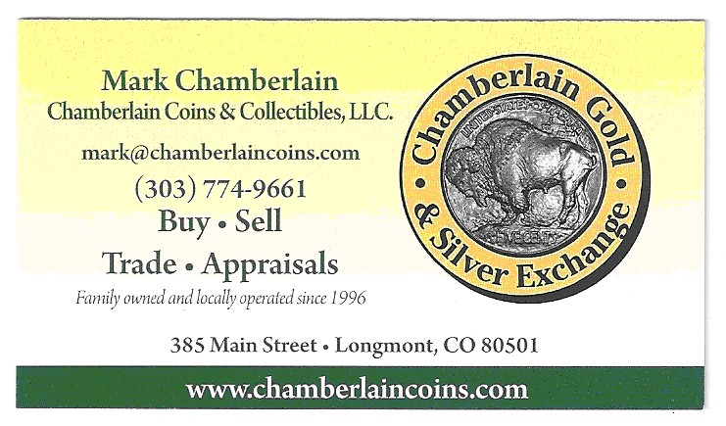
Director: Glen Dinner 970-301-2700 gadfly8866@msn.com
Director: Ken Davis 303-772-6706 krdavis334@msn.com
Director: David Feely 303-772-7690 keycamera@yahoo.com

FRCC Newsletter Advertisers

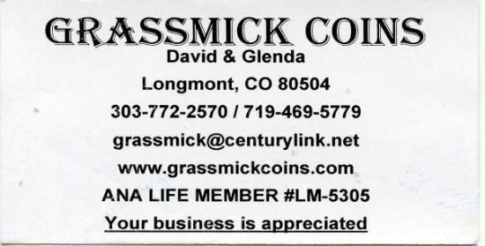
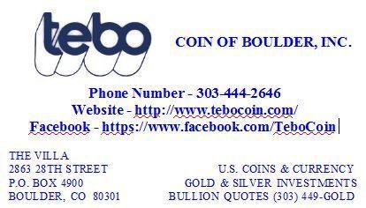

The next FRCC Monthly Meeting will be held on Thursday, March
12th, 2026 @ 7:00 PM

Page 5

