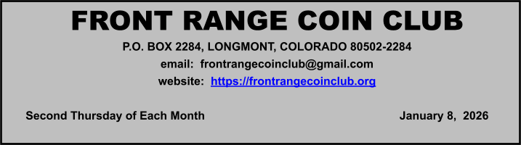

April

12
th

MeetiMinutes

Attendance

19 members attended.

Meeting Minutes

Old Business:

No old business was discussed at the meeting.

New Business:

No new business.

President’s Corner

President Dave Jaeger the silver industry and deals that can affect the price of silver.

Presentation(s)

No presentation,

Treasurer’s Report

Bob L. reported the club bank account balance was $17,973.35.

Drawings/Door Prizes

Dalton J. and Jim G. won prizes.

Coin and Currency News

Stack's Bowers | Last “Omega” Pennies
Sell for Over $16.76 Million in Stack’s Bowers Galleries Auction

The very last circulating pennies, or “cents,” sold for over $16.76 million in a special auction by Stack’s Bowers Galleries on Thursday, December 12th, presented on behalf of the United States Mint. Included in the sale were 232 three-coin sets featuring one each of the 2025 penny struck at the Philadelphia Mint, the 2025-D penny struck at the Denver Mint, and a historic 2025 penny struck in 24 karat gold also at the Philadelphia Mint. Each of these special coins exhibits a small “Ω” privy mark of the final Greek letter Omega, indicating their role as the capstone to a two-centuries long legacy that first began in 1793 with the Chain Cent.

Upcoming Programs

Paul DeFelice, VP or Marketing and Client Relations for ANACS, will be the guest speaker at the next Front Range Coin Club meeting on Feb 12th. Paul is a graduate of Bentley University in Waltham, MA, and has been called “The Face of ANACS”. He can often be found at coin shows across the country or as a guest-speaker at many of the coin clubs in Colorado.

Local Area Coin Clubs

*On average, doors open 30 minutes before the start of a meeting:

Front Range Coin Club:
7:00 PM, Christ Our Savior Lutheran Church, 640 Alpine St, Longmont, CO; 2nd Thursday monthly.

Northside Coin Club:
7:00 PM, Cross of Christ Lutheran Church, 12099 Lowell Blvd, Broomfield, CO; 2nd Tuesday monthly.

South Suburban & DAWN Coin Club:
6:00 PM, Calvary South Denver Church,
9052 W Ken Caryl Ave, Littleton, CO 80128;
2nd Tuesday monthly.

Denver Coin Club:
7:00 PM, Salem United Church of Christ, 5300 E. Florida Ave, Denver, CO; Last Thursday monthly.

Fort Collins Coin Club:
6:30 PM, Senior Center, 1200 Raintree
Drive, Fort Collins, CO;
1st Friday monthly except July & December.

Greeley Coin Club:
7:00 PM, Moose Lodge, 3456 11th Ave,
Evans, CO;
2nd Tuesday monthly. No meetings in July and August.

Cheyenne Coin Club:
7:00 PM, Ascension Lutheran Church, 712 Storey Boulevard, Cheyenne, WY; 3rd Tuesday monthly.

2026 Coin Shows
March:
14th-15th | Front Range Coin Club Spring  Coins & Collectibles Show  Boulder County Fairgrounds, Bldg A  9595 Nelson Road  Longmont, CO 80501  Ken Davis, 303-772-6706
March:
20th-22nd | Fort Collins Coin Club Spring  Coin Show  Larimer County Fairgrounds - McKee 4-H  Bldg.5280 Arena Circle  Loveland, CO 80538

April/May:
April 30th  - May 2nd | Denver Coin Expo  National Western Complex 4655 Humboldt St.  Denver, CO 80216

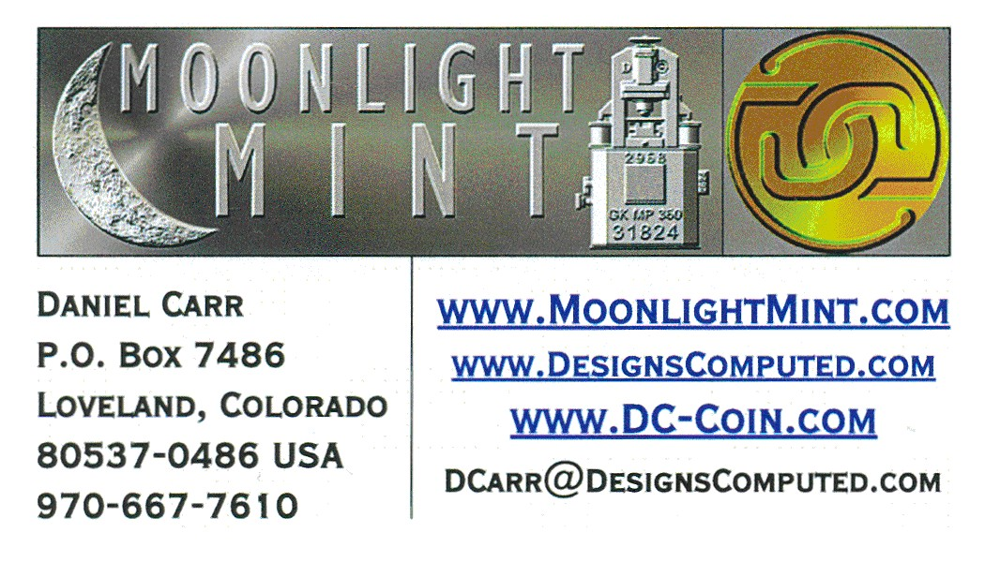
Contact Us - 2026 FRCC Officers

President: Dave Jaeger 970-310-4873 davejaeg@gmail.com
Vice President: Joe Garguilo 303-651-2877
m5joe@yahoo.com
Coin Show Dir: Ken Davis 303-772-6706 krdavis334@msn.com
Secretary: John Flahive 262-665-2025
bcwatchman@gmail.com
Treasurer: Bob Liberatore 303-651-1091 ontimeappr@msn.com
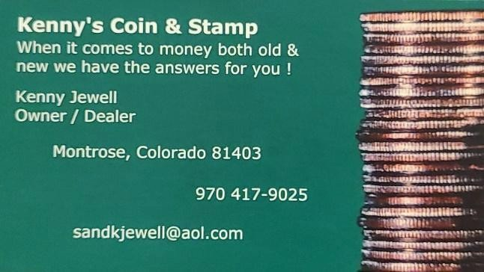
Newsletter: John Flahive 262-665-2025 frcc.org@gmail.com

2026 FRCC Board of Directors

Director: Dan Carr 970-667-7610 dcarr@MoonlightMint.com Director: Glen Dinner 970-301-2700
gadfly8866@msn.com
Director: Ken Davis 303-772-6706

krdavis334@msn.com
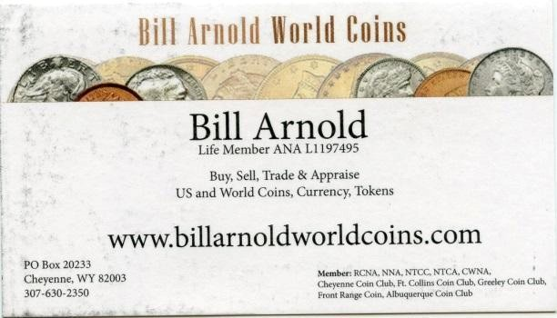
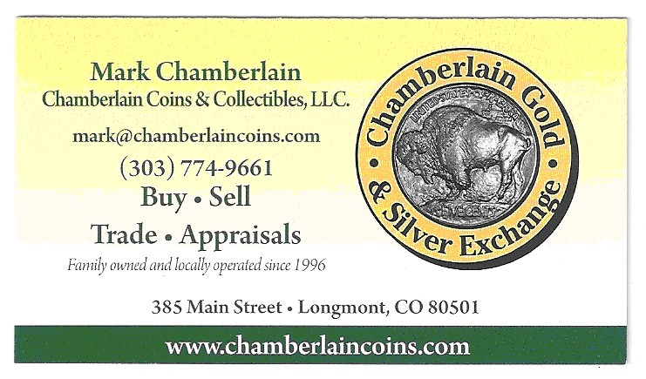
Director: David Feely 303-772-7690 keycamera@yahoo.com

FRCC Newsletter Advertisers

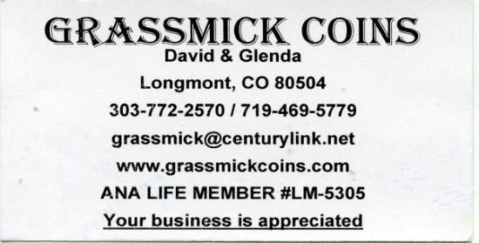
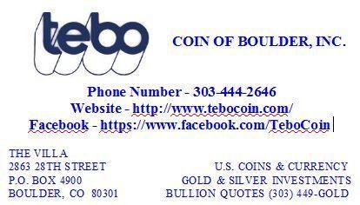

The next FRCC Monthly Meeting will be held on Thursday,
February 12th, 2026 @ 7:00 PM

