FRONT RANGE COIN CLUB
P.O. BOX 2284, LONGMONT, COLORADO 80502-2284
email: frontrangecoinclub@gmail.com

website: https://frontrangecoinclub.org

Second Thursday of Each Month April 12th Meeting Minutes February 2024

Attendance

22 members were in attendance.

Meeting Minutes

New Business:

The Front Range Coin Show was held March 9th and 10th. Thank you to all our volunteers who helped to make the show a great success. Look for more photos and details in the next newsletter, as the amount of show traffic and financial outcomes will be reported at the upcoming meeting on March 14th.

The ANA’s National Money Show will be held at the Broadmoor Resort in Colorado Springs March 14th through 16th.

The Fort Collins Coin Show in March will be on the 22nd through 24th at the Larimer County Fairgrounds.

Additionally, further FRCC club medal development has been tabled until later in the year.

Presentation(s)

President Dave J. gave a great presentation about Carson City coinage series, mintages, rarities, and tips for collecting. He showed several info tables to show estimated populations for each series and some of their values, as well as images showing several varieties and pieces in impressive condition. Dave is very knowledgeable about this topic and it was a pleasure to learn about the work produced by this historic mint from him.

Thank you, Dave, for the fine presentation!

Treasurer’s Report

Bob L. gave the monthly treasurer’s report:

Current balance: $20,764.89

As of this time, most of the show expenses are for the upcoming show were paid.

Club dues for 2024 membership are now owed. Dues are currently $2 per person, or $5 for a family membership. Please pay Bob L. promptly.

Drawings/Door Prizes

The January silver coin drawing was held.
The coin won was an 1882-S Morgan Dollar.
The winner was Ron W.!

The monthly door prize drawings were held.
The prizes were two pairs of mercury dimes.

The winners were David F. and Cheryl V.!

The 1st quarterly gold coin drawing of 2024 will be held on Thursday, March 14th at the club meeting. The price per ticket is currently $2.00. The prize will be a 2009 1/10 oz Gold Eagle.

New Coin News

Proposed New Designs Contemplated for 2026 Cent and Nickel:

https://www.coinworld.com/news/uscoins/ccac-concurs-with-cfa-on-2026-centsand-5-cent-coins

2000 lots of Ancient, Islamic, Indian,
Chinese, and World Coins star in
Upcoming Auction

https://www.numismaticnews.net/worldcoins/2000-lots-of-ancient-islamic-indianchinese-and-world-coins-star-in-upcomingauction

Upcoming Programs

If you would be willing to present your favorite topic or show your collection, please let Joe Garguilo or Rebecca Murren know to schedule an event for you. If there is a topic or a discussion you would like to see/hear, let Joe or Rebecca know and they will try to get an outside presenter scheduled for a future meeting.

Local Area Coin Clubs

*On average, doors open 30 minutes before the start of a meeting:

Front Range Coin Club:
7:00 PM, Christ Our Savior Lutheran Church, 640 Alpine St, Longmont, CO; 2nd Thursday monthly.

Northside Coin Club:
7:00 PM, Cross of Christ Lutheran Church, 12099 Lowell Blvd, Broomfield, CO; 2nd Tuesday monthly.

South Suburban & DAWN Coin Club:
6:00 PM, Calvary South Denver Church, 9052 W Ken Caryl Ave, Littleton, CO 80128; 2nd Tuesday monthly.

Denver Coin Club:
7:00 PM, Salem United Church of Christ, 5300 E. Florida Ave, Denver, CO; Last Thursday monthly.

Fort Collins Coin Club:
6:30 PM, Senior Center, 1200 Raintree Drive, Fort Collins, CO; 1st Friday monthly except July & December.

Greeley Coin Club:
7:00 PM, Moose Lodge, 3456 11th Ave, Evans, CO; 2nd Tuesday monthly. No meetings July and August.

Cheyenne Coin Club:
7:00 PM, Ascension Lutheran Church, 712 Storey Boulevard, Cheyenne, WY; 3rd Tuesday monthly.

2024 Coin Shows July:
13th | Greeley Coin Club Show  Greeley, CO  Dave Feely, 303-772-7690
25th-28th | CK Las Vegas  Dawn, 888-330-5150
19th-20th | Wasatch Winter Coin Show  Sandy, UT  Bob Campbell, 801-467-8636
26th-27th | Denver Coin Club Show  Denver Kicker’s Club Fieldhouse, Golden  Steve Sellers, 303-246-4489
2nd-3rd | Denver Stamp Club Show  Kenny Luke, 303-598-7198
10th-11th | WYPEX 2024  Laramie County Community College,  Cheyenne, WY  Bill Arnold, 307-630-2350
9th-10th | Front Range Coin Club Spring Show  Boulder Cty Fairgrounds, Longmont, CO  Ken Davis, 303-772-6706
13th-16th | ANA National Money Show The Broadmoor, CO Springs, CO conventions@money.org
22nd-24th | Fort Collins Coin Club Show  Larimer Cty Fairgrounds, Loveland, CO  Jim Oscarson, 970-294-3385
24th -26th | Las Vegas Numis. Soc. Coin Show by CK Shows  Palace Station Hotel & Casino, Las Vegas,  NV  Dawn, 888-330-5188
13th-14th | CHERPEX  Jefferson Cty Fairgrounds  Kenny Luke, 303-598-7198
21st-22nd | Front Range Coin Club Fall Show  Boulder County Fairgrounds, Longmont,  CO  Ken Davis, 303-772-6706
10th-12th | Denver Coin Expo  National Western Complex, Denver, CO  Neal Hatgi, 720-773-1175
21st-22nd | Western Slope Coin Club Fall Show  Grand Junction, CO  Lewis Miller, 970-640-3765
31st-2nd | Las Vegas National by CK Show  Tuscany Casino, Las Vegas, NV  Dawn, 888-330-5150
19th-21st | Albuquerque Coin Club Spring Show  Marriott Pyramid North, Albuquerque, NM  Matt Peacock, 505-270-8685
26th-27th | Western Slope Coin Club Spring Show  Grand Junction, CO  Lewis Miller, 970-640-3765
January:
August:
March:
September:
October:
April:
^{May:} November:
9th-11th Denver Coin Expo National Western Complex, Denver, CO Neal Hatgi, 720-773-1175  26th-28th ROMPEX Arapaho County Fairgrounds, Aurora, CO Ron Lampo, 720-771-0841 | 8th-10th Albuquerque Coin Club Fall Show Marriott Pyramid North, Albuquerque, NM Matt Peacock, 505-270-8685  22nd-23rd Cheyenne Coin, Currency, Tokens, & Collectibles Show Bill Arnold, 307-630-2350
June: December:
21st-23rd Colorado Springs Coin Club Show | 7th Fort Collins Coin Club Show Lincoln Center, Fort Collins, CO Jim Oscarson, 970-294-3385

Contact Us - 2024 FRCC Officers

President: Dave Jaeger 970-310-4873 davejaeg@gmail.com
Vice President: Joe Garguilo 303-651-2877
m5joe@yahoo.com
Coin Show Dir: Ken Davis 303-772-6706
 | krdavis334@msn.com
Secretary: | Dalton Jenkins 303-646-7853
 | dalton@clodiusandco.com
Treasurer: | Bob Liberatore 303-651-1091
 | ontimeappr@msn.com
Newsletter: | Dalton Jenkins 303-646-7853
 | dalton@clodiusandco.com

2024 FRCC Board of Directors

Director: | Dan Carr 970-667-7610
 | dcarr@MoonlightMint.com
Director: | Glen Dinner 970-301-2700
 | gadfly8866@msn.com
Director: | Ken Davis 303-772-6706
 | krdavis334@msn.com
Director: | David Feely 303-772-7690
 | keycamera@yahoo.com

FRCC Newsletter Advertisers

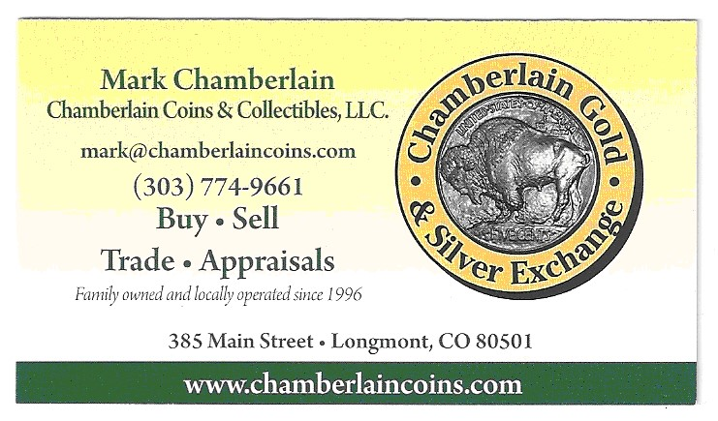

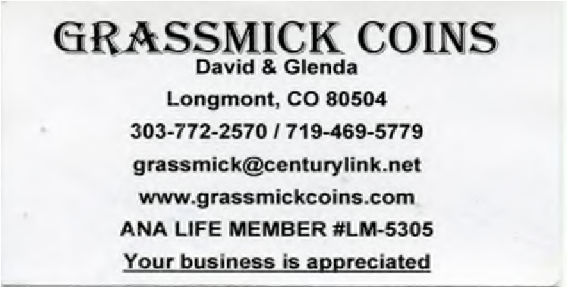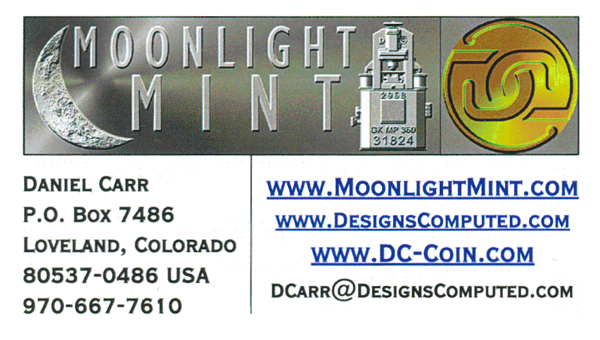

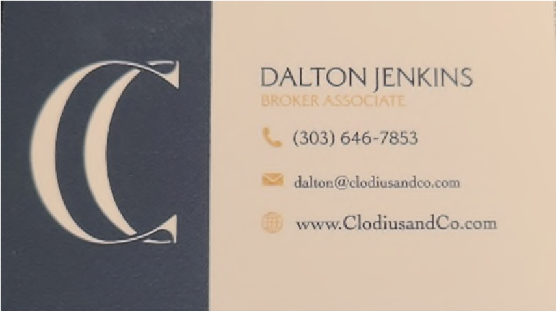
Clodius and Co. Real Estate

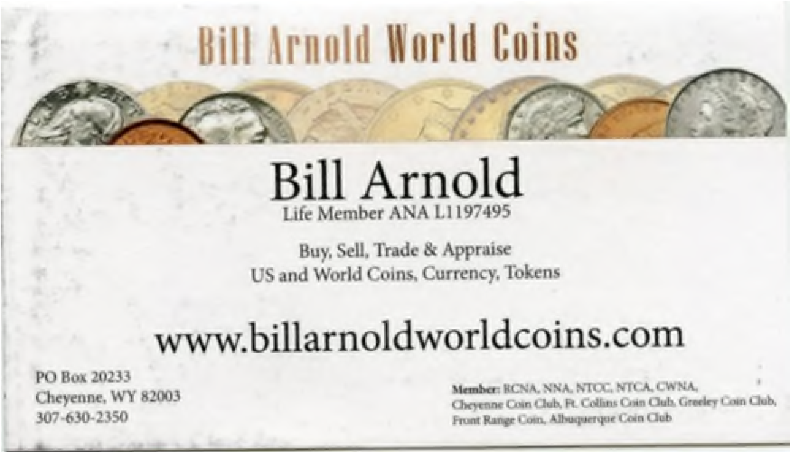

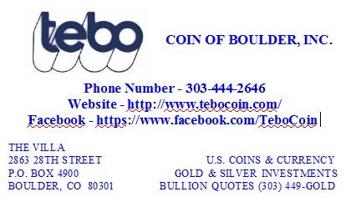

The next FRCC Monthly Meeting will be held:

Thursday, March 14th, 2024 @ 7:00 PM

Christ Our Savior Lutheran Church, 640 Alpine St, Longmont, CO 80504

Page 6

